Why Concurrency:
How do we handle two or more transactions trying to update the same data at the same time?
Transactions:
Execution of a sequence of one or more operations.
In SQL, a new transaction starts with the BEGIN command. Then the transaction stops with either COMMIT or ABORT.
Aborts can be invoked by the application or the DBMS (in which case the DBMS needs a way to communicate the abort to the application).
ACID
A set of rules that ensure a reliable transaction
- Atomicity: Atomicity ensures that either all actions in the transaction happen, or none happen.
- Consistency: If each transaction is consistent and the database is consistent at the beginning of the transaction, then the database is guaranteed to be consistent when the transaction completes. Data is consistent if it satisfies all validation rules such as constraints, cascades and triggers.
- Isolation: Isolation means that when a transaction executes, it should have the illusion that it is isolated from other transactions. Isolation ensures that concurrent execution of transactions should have the same resulting database state as a sequential execution of the transactions.
- Durability: If a transaction commits, then its effects on the database should persist no matter what happens (e.g. power failure, OS crash).

Atomicity
The DBMS guarantees that transactions are atomic. From application’s point of view: the transaction either executes all its actions or none of them. Two possible outcomes of executing a transaction:
- Commit: Commit after completing all its actions
- Abort: Abort (or be aborted by the DBMS) after executing some actions
There are two approaches to ensure atomicity:
Logging
DBMS logs all actions in an ordered ledger so that it can undo the actions in case of an aborted transaction. It maintains undo records both in memory and on disk. The logs will be replayed after crash to put database back in correct state.

Shadow Paging
The DBMS makes copies of pages modified by the transactions and transactions make changes to those copies. Only when the transaction successfully commits, is the page made visible to other transactions. This approach is typically slower at runtime than a logging-based DBMS. However, one benefit is, if you are only single threaded, there is no need for logging, so there are less writes to disk when transactions modify the database. This also makes recovery instant and simple, as all you need to do is delete all pages from uncommitted transactions.

Consistency
the database is logically correct. SQL has methods to specify integrity constraints (CHECK, ADD CONSTRAINT) and the DBMS will enforce them. Then it is up to the application to define these constraints. The DBMS is responsible for ensuring that all integrity constraints are true before and after the transaction ends.

Isolation
DBMS provides transactions the illusion that they are running alone in the system. They do not see the effects of concurrent transactions. This is equivalent to a system where transactions are executed in serial order (i.e., one at a time). But to achieve better performance, the DBMS has to interleave the operations of concurrent transactions while maintaining the illusion of isolation.
interleaving of operations can lead to:
- Temporary Inconsistency: Unavoidable, but not an issue.
- Permanent Inconsistency: Unacceptable, cause problems with correctness and integrity of data.
A concurrency control protocol is how the DBMS decides the proper interleaving of operations from multiple transactions at runtime.
Types:
- Pessimistic: The DBMS assumes that transactions will conflict, so it doesn’t let problems arise in the first place.
- Optimistic: The DBMS assumes that conflicts between transactions are rare, so it chooses to deal with conflicts after they happen.

The order in which the DBMS executes operations is called an execution schedule. We want to interleave transactions to maximize concurrency while ensuring that the output is correct. The goal of a concurrency control protocol is to generate an execution schedule that is is equivalent to some serial execution:
- Serial Schedule: Schedule that does not interleave the actions of different transactions.
- Equivalent Schedules: For any database state, if the effect of executing the first schedule is identical to the effect of executing the second schedule, the two schedules are equivalent.
- Serializable Schedule: A serializable schedule is a schedule that is equivalent to some serial execution of the transactions. Different serial executions can produce different results, but all are considered “correct”. Note that if each transaction preserves the consistency, every serializable schedule also preserves the consistency.
A conflict between two operations occurs if the operations are for different transactions and they are performed on the same object.
Read-Write Conflicts: A transaction is not able to get the same value when reading the same object multiple times.
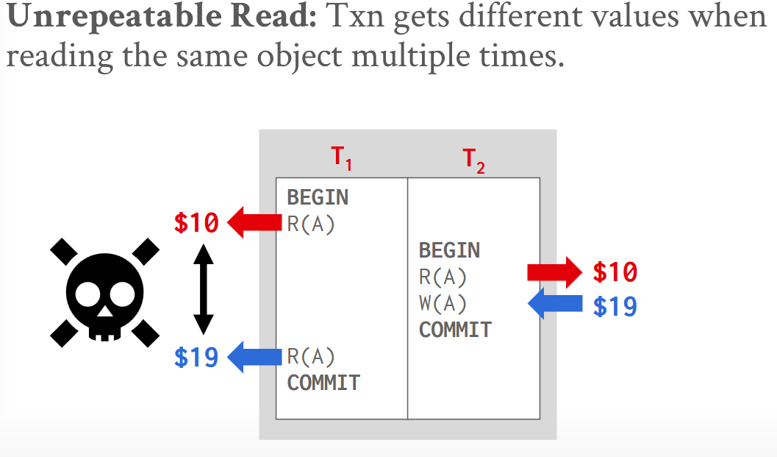
Write-Read Conflicts: A transaction sees the write effects of a different transaction before that transaction commits its changes.
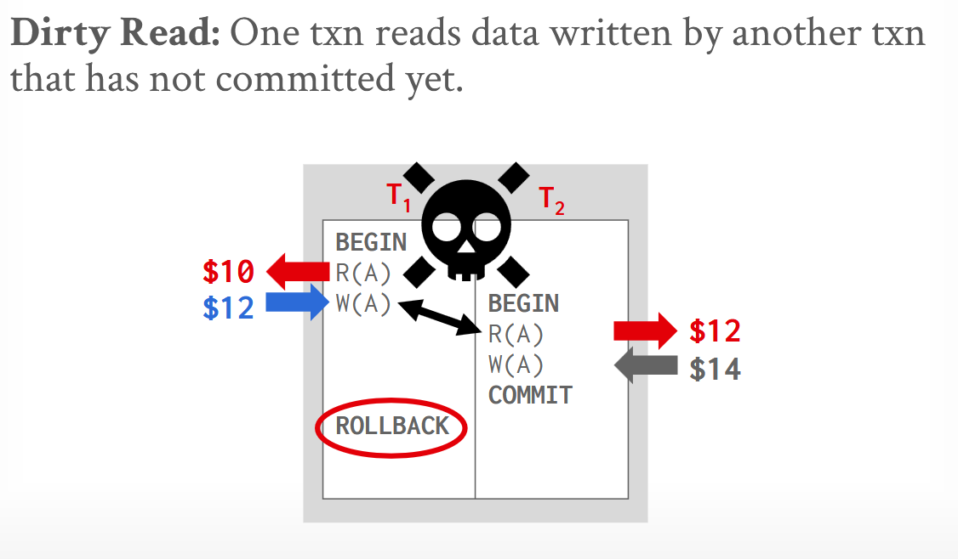

Write-Write Conflicts: One transaction overwrites the uncommitted data ofanother uncommitted transaction.
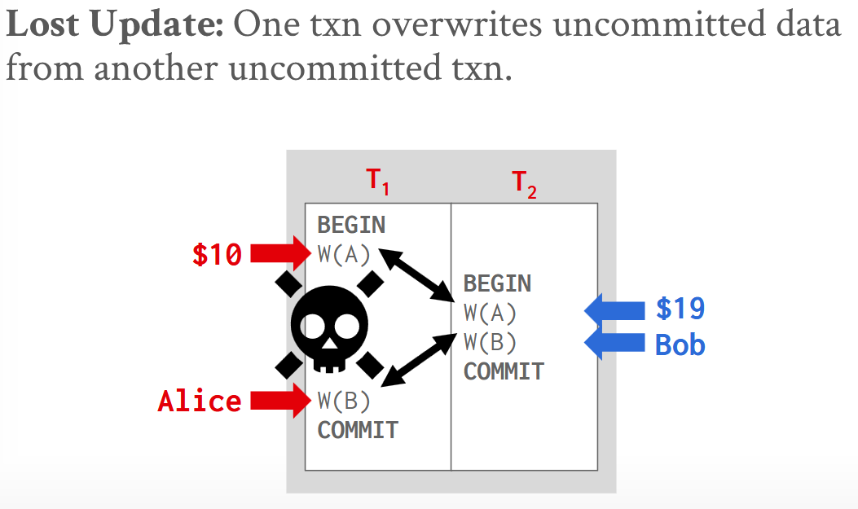

Conflict Serializable: A schedule is "conflict serializable" if it is equivalent to a schedule where transactions run strictly one at a time (a serial schedule).
Instead of slowly rearranging individual steps to see if they form a one-at-a-time schedule, it is much faster to use a dependency graph:
- Make a dot (node) for each transaction.
- Draw an arrow from Transaction A to Transaction B if they have conflicting steps and A goes first.
If the graph has no loops (is acyclic), the schedule is conflict serializable.
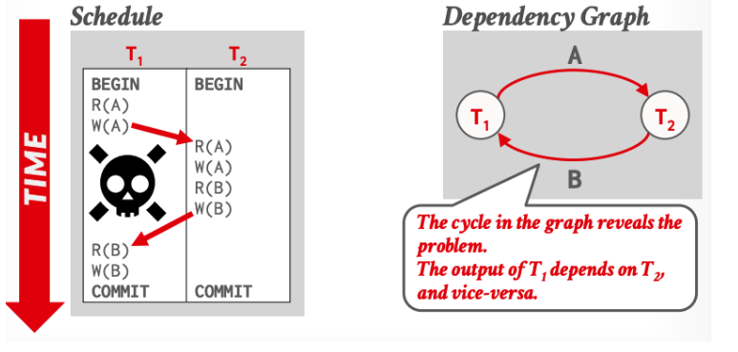

Durability
Once a transaction finishes successfully, its changes must be saved permanently to survive any system crashes or restarts. This guarantees that data is never left half-updated and that mistakes from failed operations are wiped away. Databases achieve this by saving the completed work to permanent storage, using backup methods like logging or shadow paging.

